Safety Photo #1
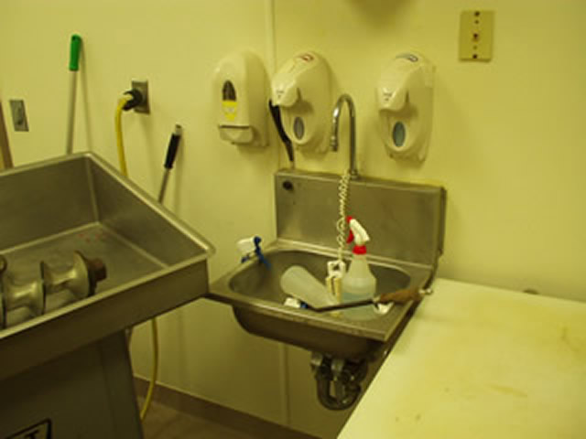

- Hand wash sinks and equipment wash sinks shall not be used to store soiled or clean equipment, supplies or packaging containers.
- All hand wash sinks in food operation and toilet areas shall be clean and sanitary, with cold and hot water and proper temperature controls and mixing valves and accessible at all times.
- Both A and B
- Only company approved and properly labeled chemicals may be used for cleaning the processing equipment and plant work areas.
- All of the above.
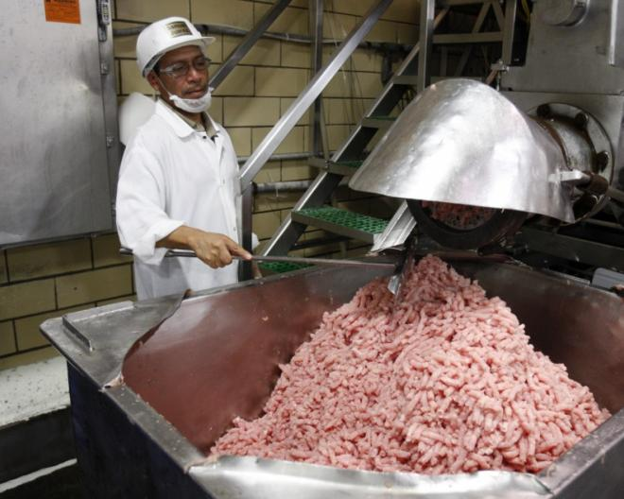
Safety Photo #2

- Equipment, facilities, walls and floors, and overhead utilities must be dirt, dust, mold, or otherwise contamination-free.
- All food contact surfaces shall be constructed of heavy stainless steel, or of food grade quality sanitary plastic or rubber.
- Food handling employees shall wear clean, impact-resistant, sanitary gloves made of impermeable plastic or rubber whenever in direct contact with foods, ingredients or containers for these foods and supplies.
- No violation
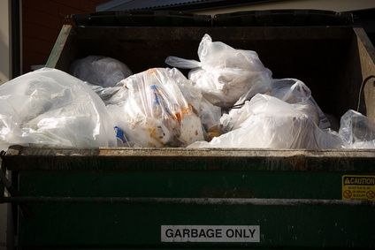
Safety Photo #3

A. This is a violation of SOP
B. Open-top trash containers (inside or out) are required to be covered.
C. This is a GMP violation.
D. Trash containers do not need to be covered therefore there is no violation.

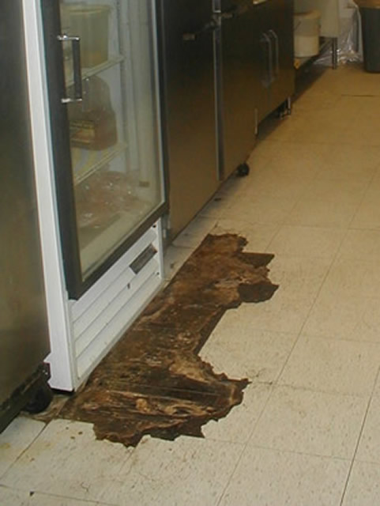
Safety Photo #4

- All floors and walls should be white in color to make visual inspection easier for USDA and FSIS employees.
- There is an SOP violation.
- Food processing plants including walls, ceilings, and floors shall be of sound and safe construction meeting regulatory guidelines, and shall be in good repair.
D. Food does not come into contact with the floor therefore there is no violation.

Safety Photo #5
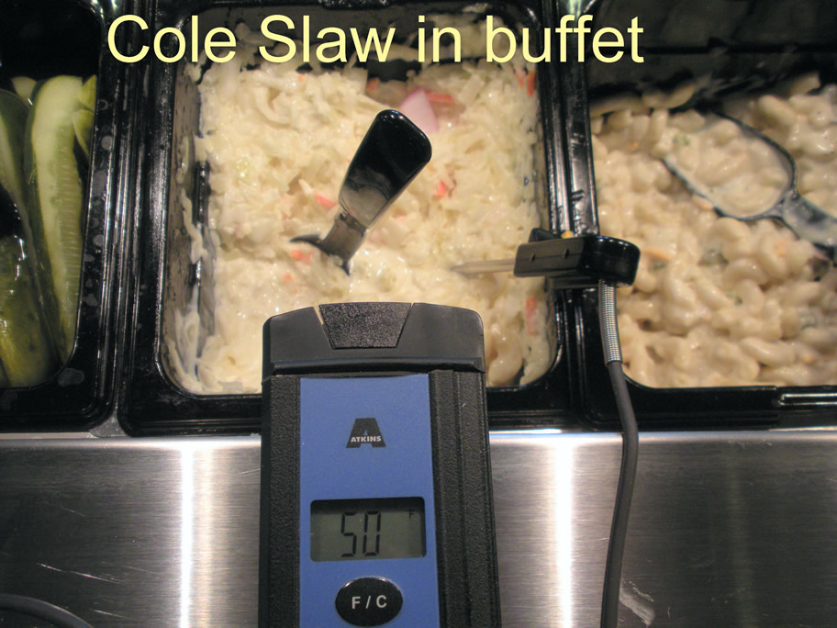

- All cold food products must be maintained at or below 40° F.
- Company SOP regulations are being followed which requires food to be stored below 50°F.
- Digital thermometers are inaccurate and are prohibited by GMP regulations for determining freezer temperatures.
D. None of the above.

Answer Key:
Safety Photo #1: C. Both A and B
Safety Photo #2: D. No violation.
Safety Photo #3: B. Open-top trash containers (inside or out) are required to be covered.

Safety Photo #4: Food processing plants including walls, ceilings, and floors shall be of sound and safe construction meeting regulatory guidelines, and shall be in good repair.

Safety Photo #5: A. All cold food products must be maintained at or below 40°F.

